1Login Page & Sign Up – Functional Test Report
Module Name: Login Page & Sign Up - Functional Test Cases
Test Case ID: str_id_01
Tester Name: Fegade Parth
Test Case Description: To validate the functionality of user registration and login workflows.
Prerequisites: 1. Stable internet connection 2. Browsers for cross-browser testing 3. Valid URL for the login and sign-up page 4. Test user credentials
Environment Information: Webpage URL: https://www.pinterest.com/

Scenario ID: a1
Scenario: Sign up
Test Steps:
- Click on Sign Up
- Enter Email
- Enter Password
- Enter Birthdate
- Click on Continue
Test Input: Valid Email, birthdate, Valid Password
Expected Results: Successfully signed up
Actual Results: Successfully sign up
Status: Pass
Comments: Tested
Screenshots:
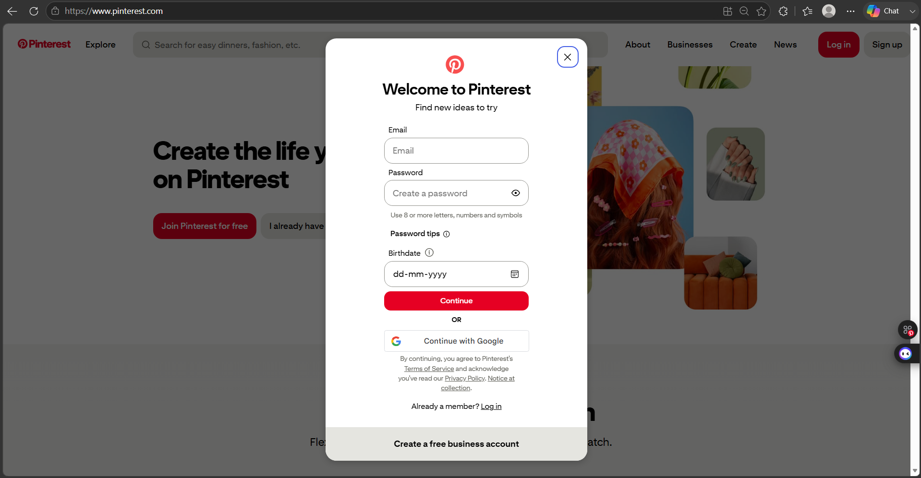

Scenario ID: a2
Scenario: Username
Test Steps:
- Enter Username
- Click on Continue
Test Input: Username
Expected Results: Successful
Actual Results: Successful
Status: Pass
Comments: Tested
Screenshots:
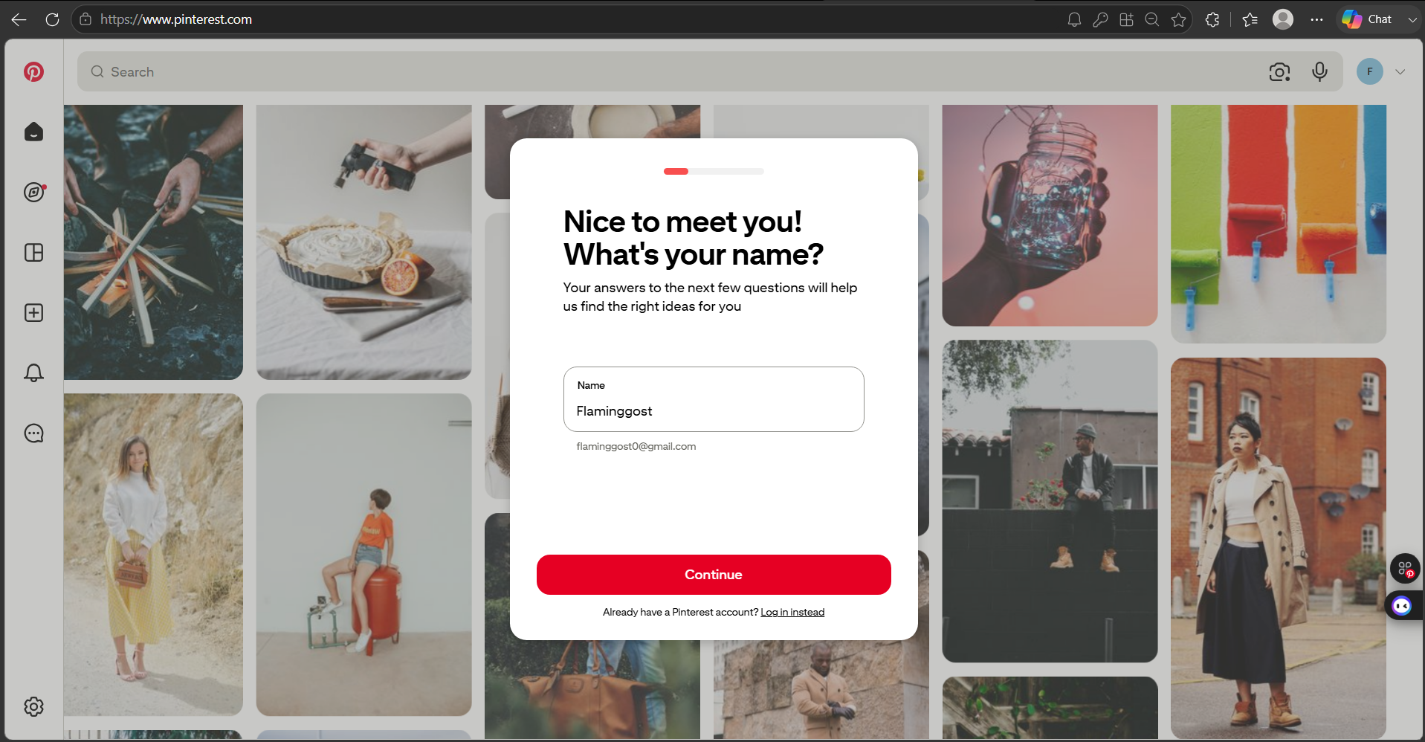

Scenario ID: a3
Scenario: Gender
Test Steps:
- Select Preferred Gender
Test Input: Click Preferred Gender
Expected Results: Successful
Actual Results: Successful
Status: Pass
Comments: There should be a Continue button
Screenshots:
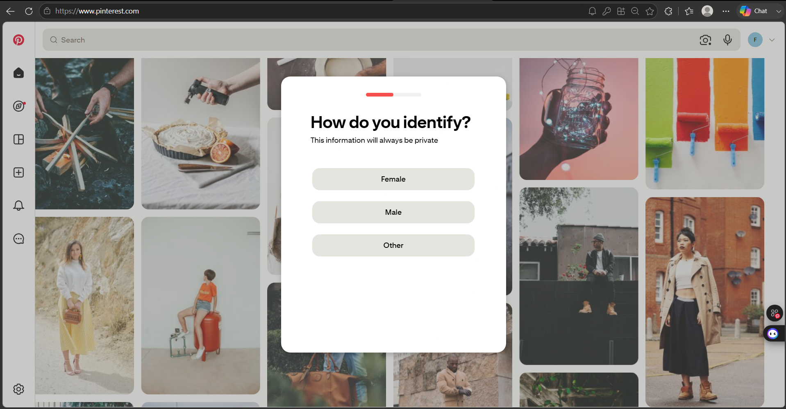

Scenario ID: a4
Scenario: Location & Language
Test Steps:
- Click on Country
- Select Country
- Click on Language
- Select Language
- Click on Continue
Test Input: Country and Language
Expected Results: Successful
Actual Results: Successful
Status: Pass
Comments: Tested
Screenshots:
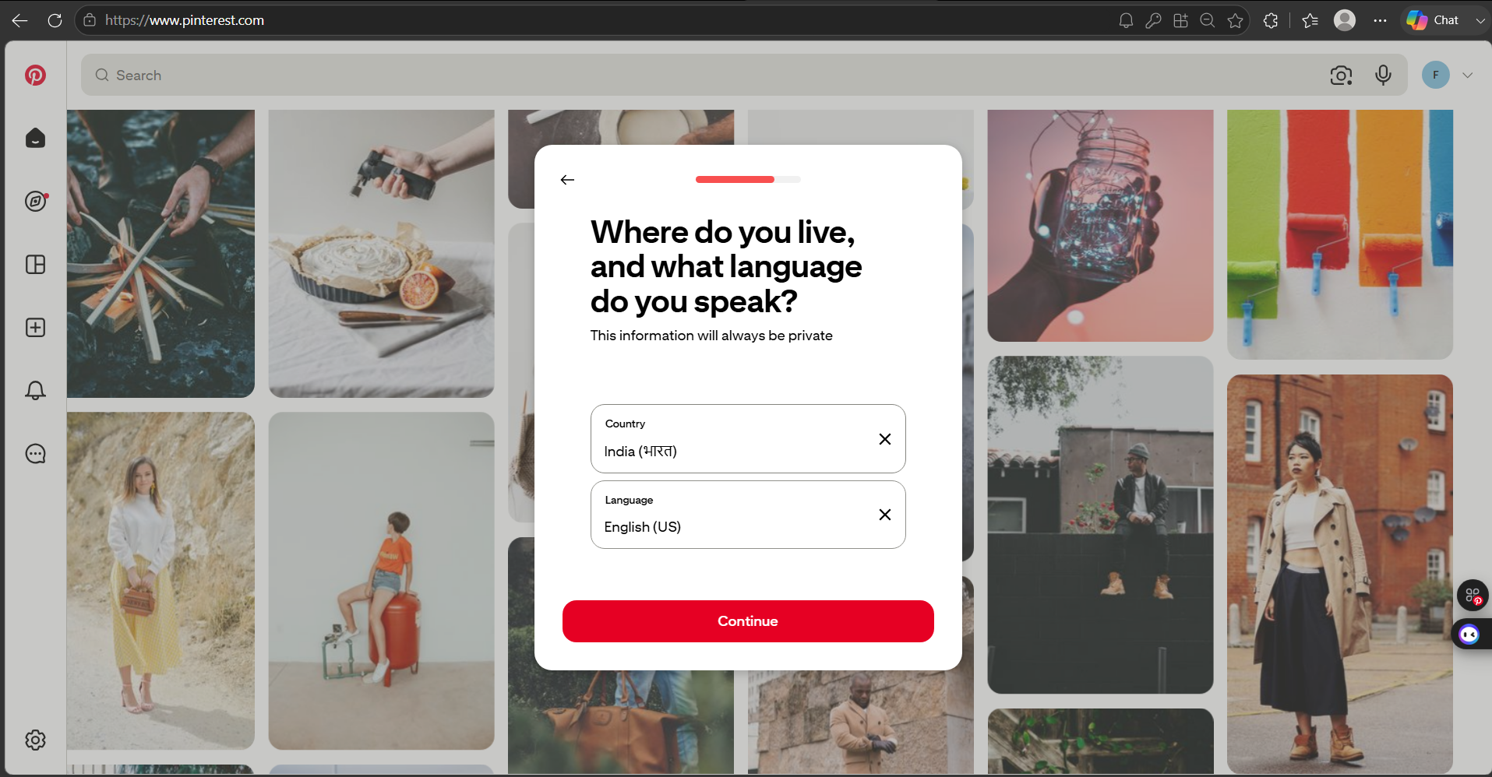

Scenario ID: a5
Scenario: Preferable interests/genre
Test Steps:
- Select preferable genre
- Use search for different genre
- Click Continue to your feed
Test Input: Preferred genre
Expected Results: Successful
Actual Results: Successful
Status: Pass
Comments: Tested
Screenshots:
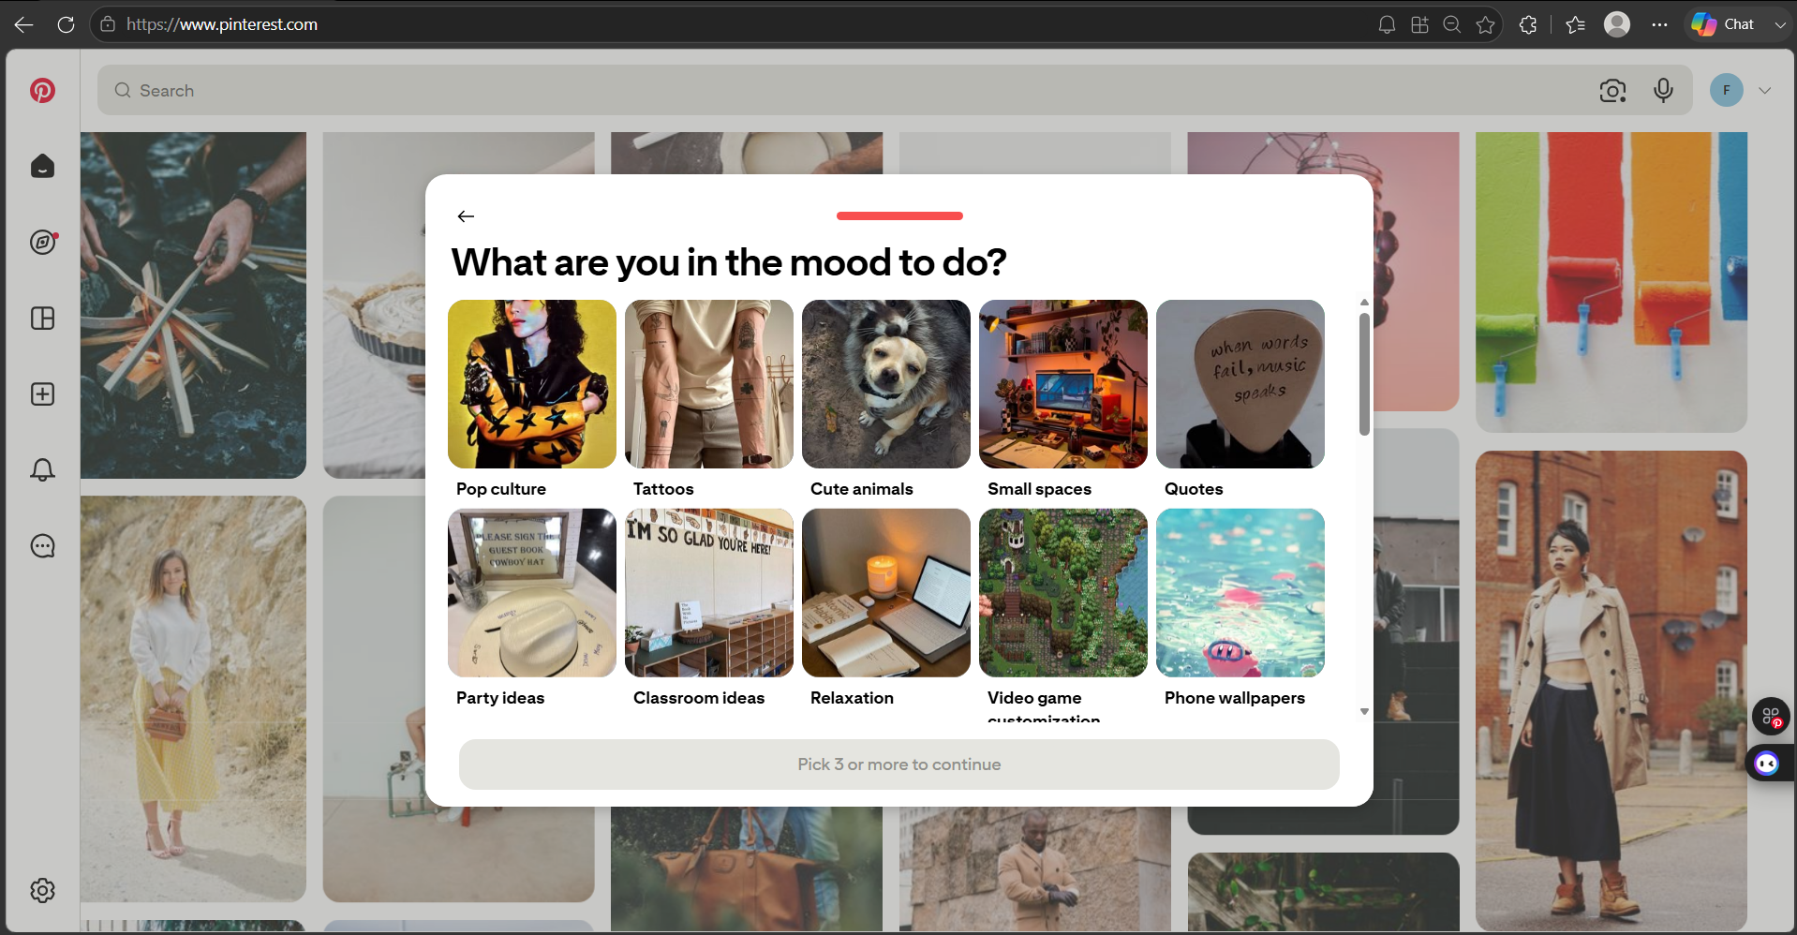

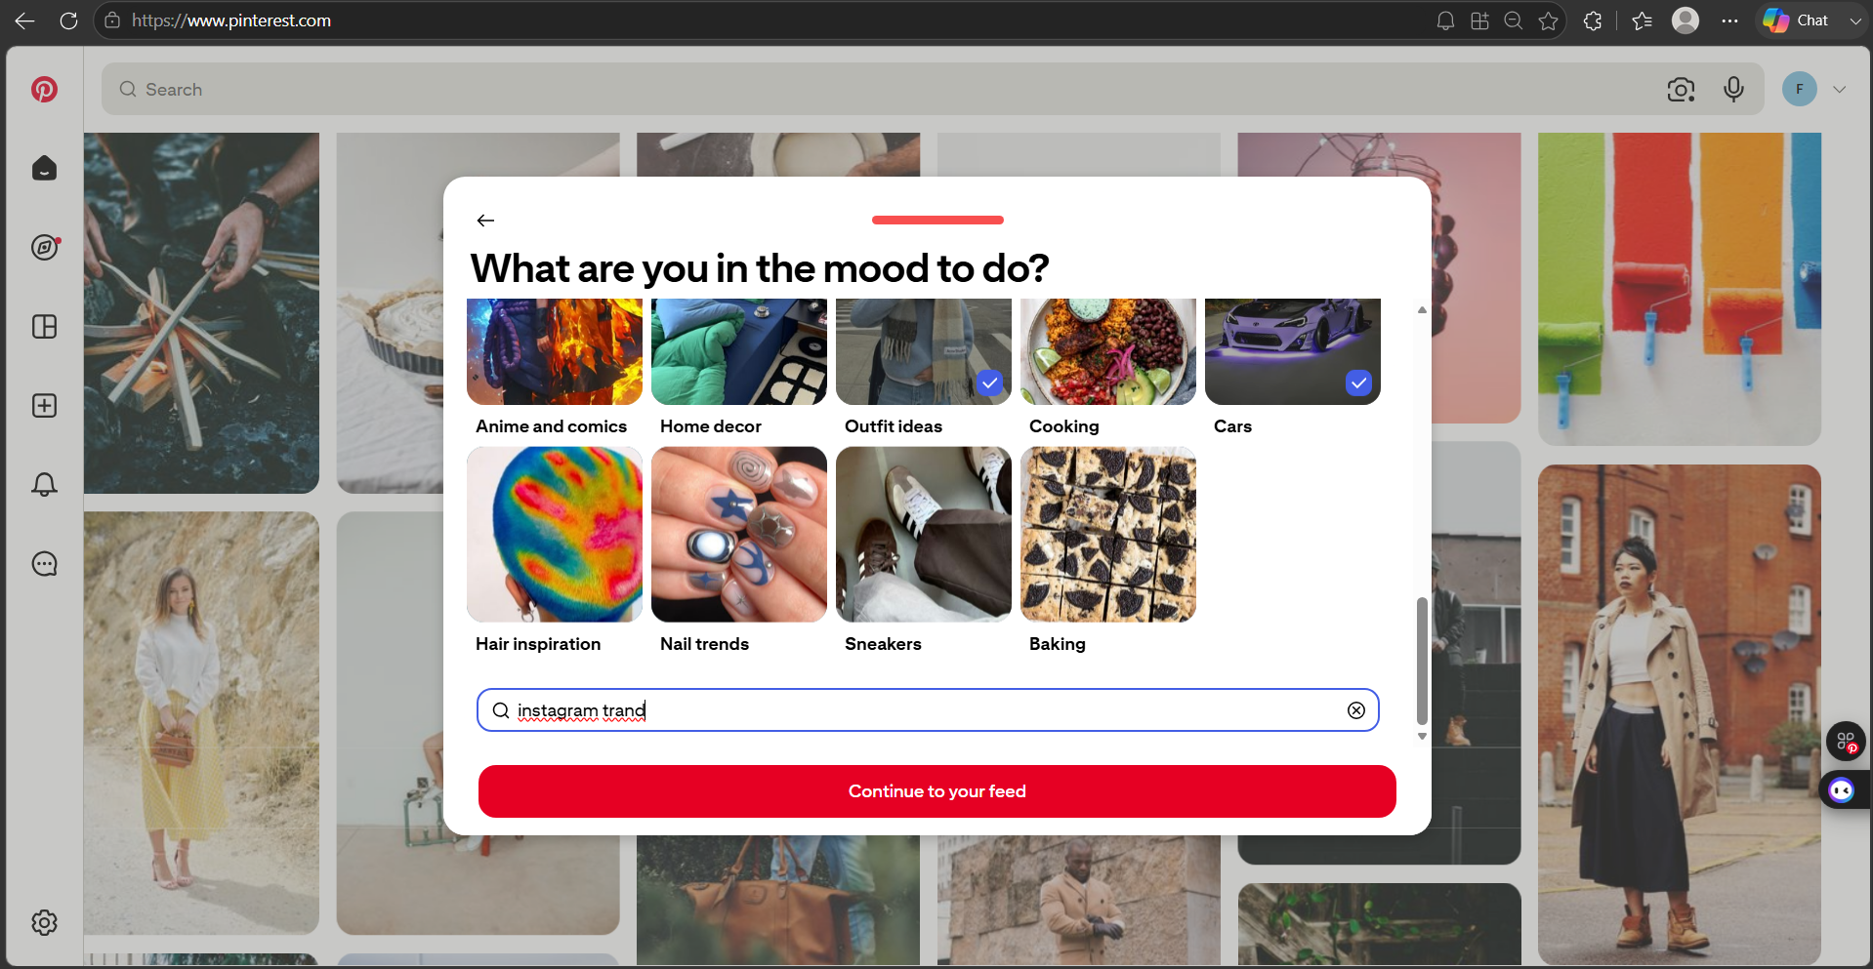

Scenario ID: a6
Scenario: Sign up (main flow)
Test Steps:
-
Test Input: -
Expected Results: Login successful
Actual Results: Main login flow
Status: Pass
Comments: Main login flow

Scenario ID: a7
Scenario: Sign up using already registered email
Test Steps:
- Enter Existing Email
- Enter Password
- Enter Birthdate
- Click on Continue
Test Input: Existing Email, birthdate, Password
Expected Results: Should show error that email is already in use
Actual Results: Hmm, wrong email or password. Try again!
Status: Fail
Comments: Pinterest needs different error messages for existing and non-existing emails
Screenshots:
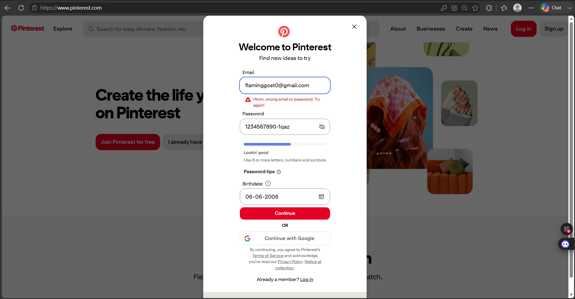

Scenario ID: b8
Scenario: Log In
Test Steps:
- Click on Log In
- Enter Email
- Enter Password
- Click on Continue
Test Input: Valid Email, Valid Password
Expected Results: Successful
Actual Results: Successfully logged in
Status: Pass
Comments: Tested
Screenshots:
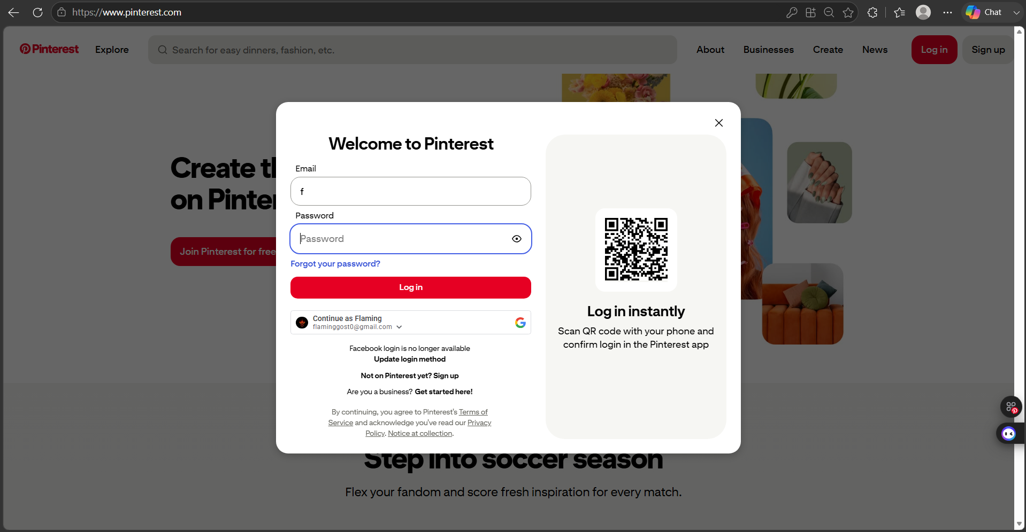

Scenario ID: c9
Scenario: Log in with incorrect password
Test Steps:
- Click on Log In
- Enter Email
- Enter Incorrect Password
- Click on Continue
Test Input: Existing Email, Incorrect Password
Expected Results: The password you entered is incorrect
Actual Results: The password you entered is incorrect. Try again or reset your password.
Status: Pass
Comments: Tested
Screenshots:
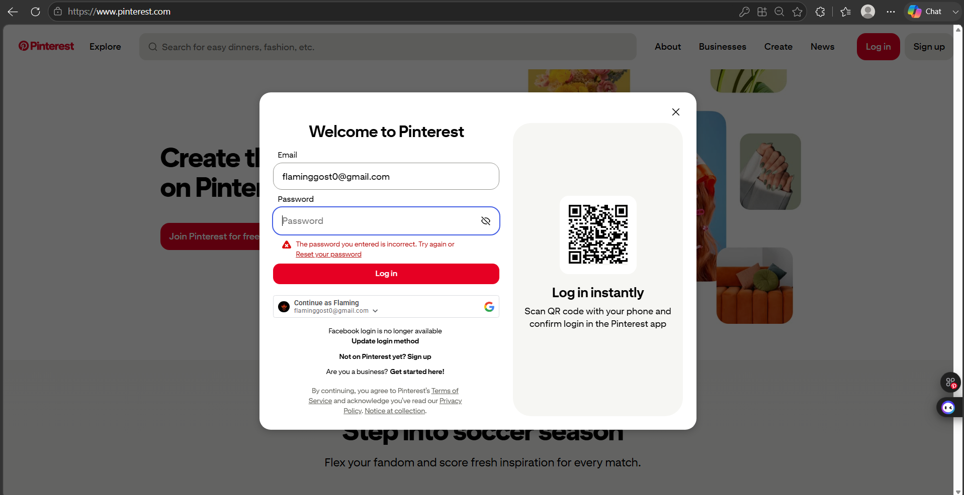

Scenario ID: d10
Scenario: Log in with incorrect email
Test Steps:
- Click on Log In
- Enter Incorrect Email
- Enter Valid Password
- Click on Continue
Test Input: Incorrect Email, Existing Password
Expected Results: The email address you entered does not exist
Actual Results: The email you entered does not belong to any account
Status: Pass
Comments: Tested
Screenshots:
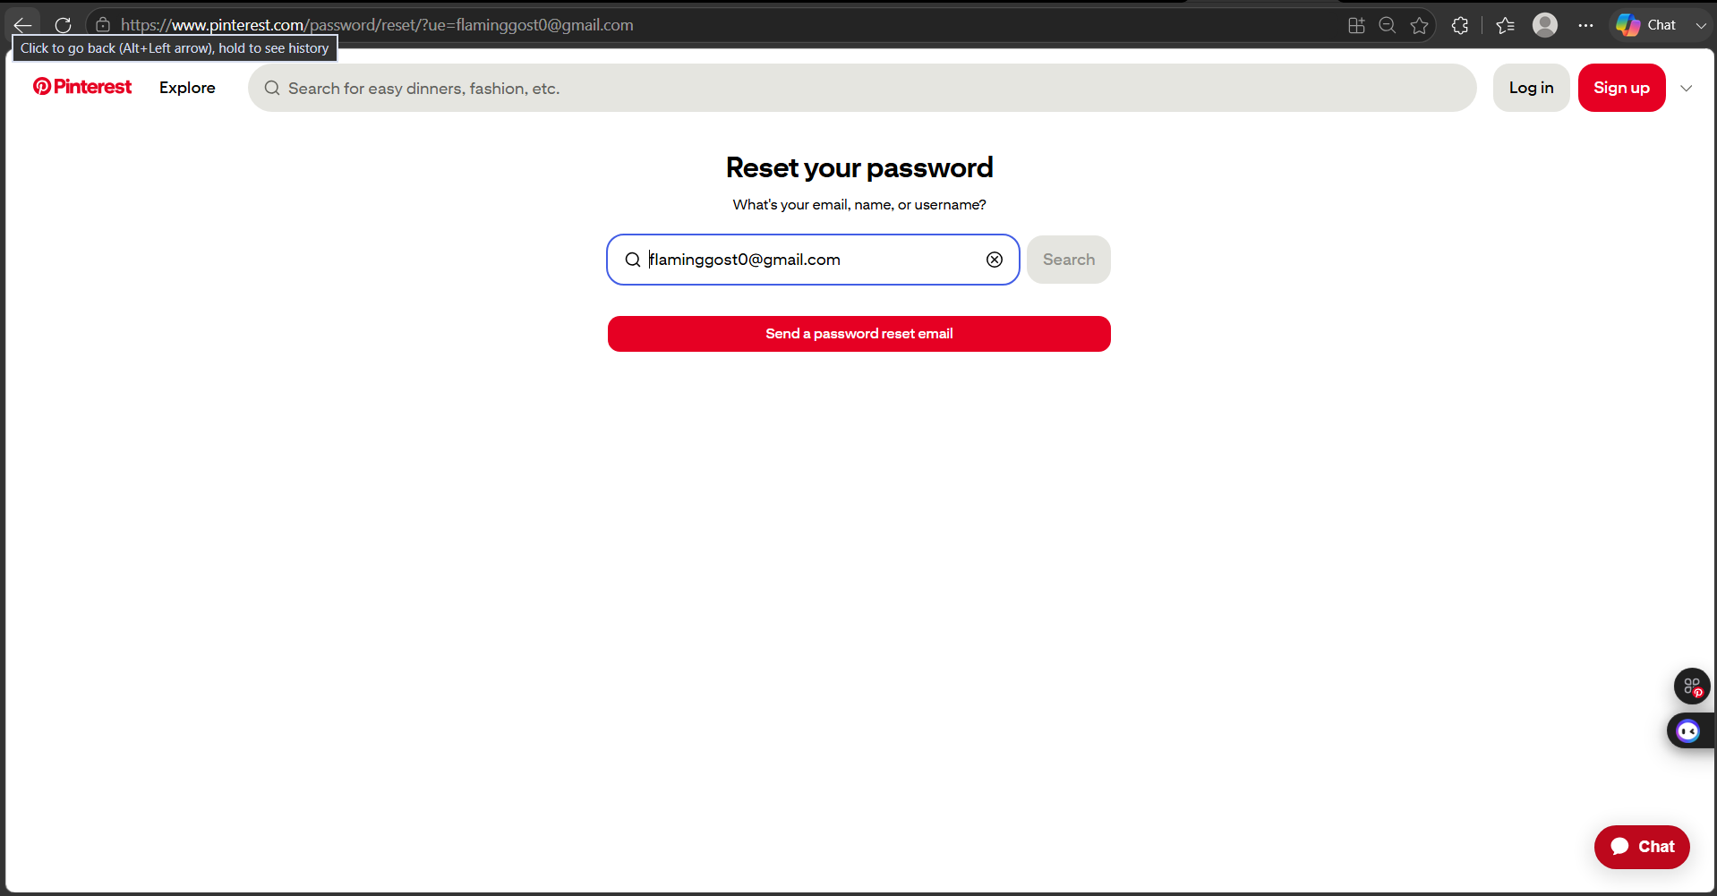

Scenario ID: e11
Scenario: Reset Password (request)
Test Steps:
- Click on forgot password
- Enter the email id
- Click send password reset email
Test Input: Click on Send Password Reset Email
Expected Results: A password reset link has been sent to your email
Actual Results: We sent an email. If this email is connected to a Pinterest account, you'll be able to reset your password.
Status: Pass
Comments: Tested
Screenshots:
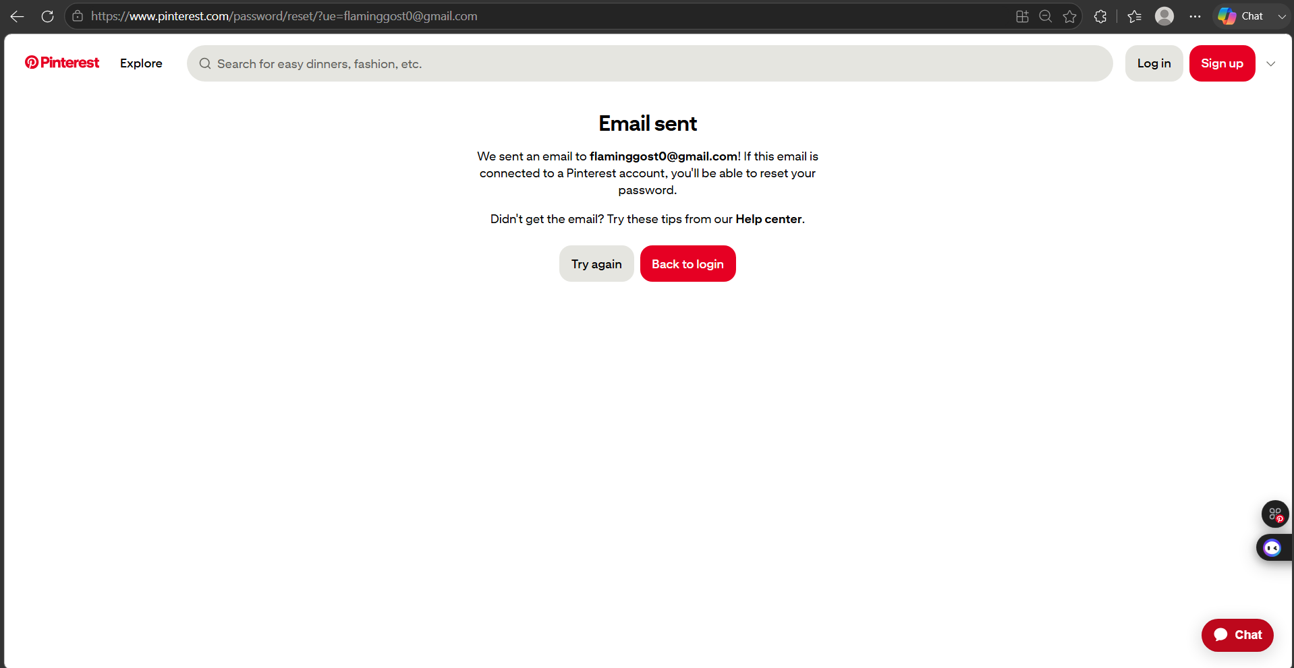

Scenario ID: e12
Scenario: Reset Password (complete)
Test Steps:
- Open Email
- Open Pinterest Email
- Click Reset Password
- Enter New Password
- Click Change Password
Test Input: New Password
Expected Results: Password reset successfully
Actual Results: -
Status: Pass
Comments: Tested
Screenshots:
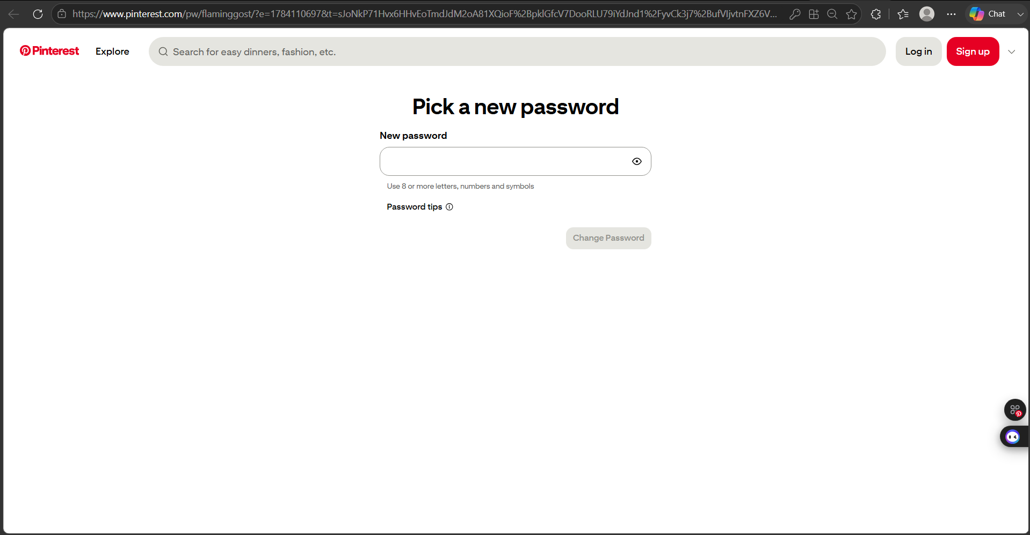

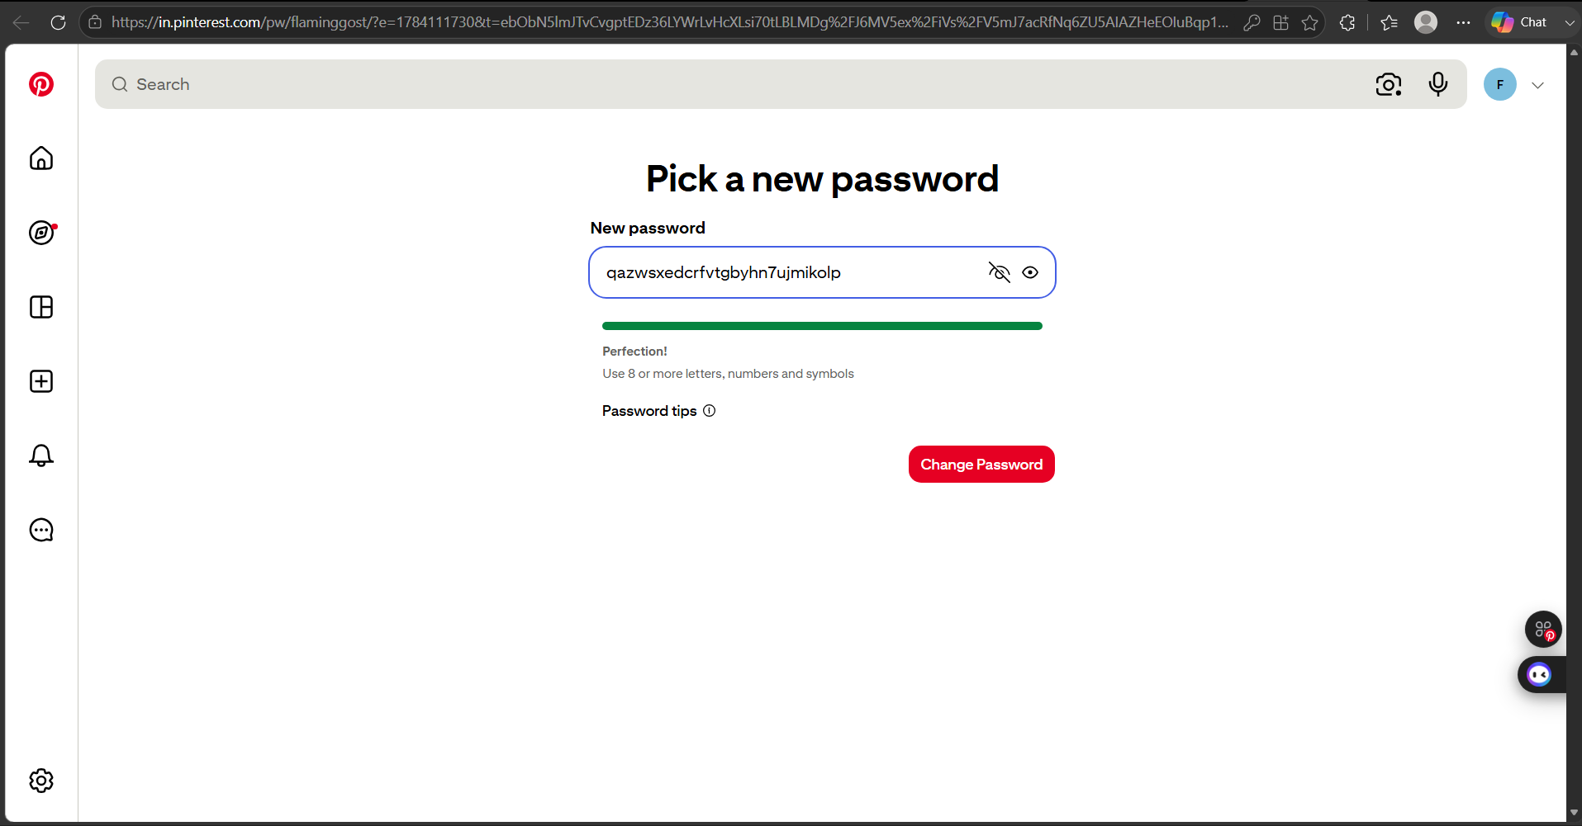

Summary of Test Results:
Total Test Cases: 12
Passed: 11
Failed: 1
Pass %: 91.67%
Conclusion and Recommendations:
Pass Rate: 91.67% — Needs Improvement
Issues Found
- Ambiguous Error on Existing-Email Sign-up (b7)
Pinterest allows sign-up submission with an already registered email but returns the generic "Hmm, wrong email or password. Try again!" message — the same message shown for incorrect login credentials — instead of a distinct "email already in use" error.
Recommendations
- Add a Distinct Error Message for Duplicate Email
Introduce a specific validation message during sign-up (e.g., "An account with this email already exists") so users can distinguish it from an incorrect-login error.
Bug Reports:
Bug ID | BUG-a7
Title | Sign-up flow shows generic login error for an already registered email
Module | Sign Up
Severity | Medium
Steps to Reproduce | 1. Enter an existing/registered email 2. Enter a password and birthdate 3. Click Continue
Expected Result | Should show error that the email is already in use
Actual Result | "Hmm, wrong email or password. Try again!" (same as incorrect-login error)

